SUBMISSION TYPE

Poster

TITLE

Generational Differences at Work: Separating Fact from Fiction

ABSTRACT

Given stereotypes attributed to employees of different generations, this project compared self-reported time spent on work and non-work activities by generation using data from the Current Population Survey and the American Time Use Survey. The results suggest that perhaps we focus more on differences between generations than is warranted.

PRESS PARAGRAPH

While there are rich benefits to generational diversity, there are often stereotypes regarding employees in different groups. For example, Millennials have been characterized as both less motivated than other generations, and at the same time, as ambitious, and “team players”. This project aims to shed light on self-reported time spent on work and non-work activities of three generations using data from the Current Population Survey and the American Time Use Survey. The results suggest that perhaps we focus more on differences between generations than is warranted. The implications for a multigenerational workforce are discussed.

WORD COUNT

2,869 (can go up to 3,000) Last year’s siop feedback at bottom of document

Within an employment context, many popular press headlines have suggested that a sound understanding of the generational differences among employees can lead to a wide range of valuable organizational outcomes, including for instance, retention, communication, employee engagement and conflict resolution. However, Becton and colleagues (2014) suggest, perceived generational differences may be a product of popular culture versus social science and that such generational differences may have a more minimal influence on organizational behaviors than is suggested by popular culture (i.e., while differences were observed in job mobility, for instance, effect sizes were small). The current paper contributes to our understanding of generational differences (or lack thereof) by approaching the question of generational differences from a novel angle – by documenting time spent on different categories of activities (e.g., working) by generation. To provide context, we first define “generations” (here, limited to the US perspective), briefly describe the theoretical approach commonly used in psychology, and highlight what we know of generational differences in the workplace.

**Generations Defined**

A generational cohort is a *demographic* cohort of people who are defined by birth year (Ryder, 1965). While on the surface, that definition is straight forward, the literature on generational differences is fraught with definitional complexities – a primary concern of which is “who falls into which category”, and even in the number of categories (e.g., PEW Research Center, Dimock, 2019; Salahuddin, 2010). Costanza et al. (2012), as part of a meta-analysis on generational differences in work attitudes, summarized the boundaries of cohort years for empirical studies, suggesting that the names are generally agreed upon across researchers, but that the years within cohorts does vary. The Baby Boom generation, for example, had starting years ranging from 1943 to 1946 and ending years from 1960 to 1969. Generation X began from 1961 to 1965 and ended between 1975 and 1981. Here, we utilize the ? categorization of generations (see Table 1), but fully acknowledge that others exist and perhaps the pattern of results would not perfectly mirror ours had another definition of categories been used.

**A Theoretical Backdrop: The Cohort Perspective**

Theory on generational differences, at least in the context of work, is somewhat less developed that our theories in other arenas (although see Dencker et al. 2008 for an interesting description of generational memories and workplace attitudes). The cohort perspective is commonly applied to the study of generational differences within psychology (Laufer & Bengtson, 1974). Laufer and Bengtson (1974) speak of the “power of the generational factor” (p. 187). Here, a “cohort effect” references similarities in experiences for those of a specific age range (defined by birth year). Although individual differences in experiences and values certainly shape a person, the cohort perspective takes a much larger lens, considering major events, as well as social, political, and cultural occurrences of their time. Jones et al. (2018) in a review of generational differences, note that generational differences or stereotypes are region-specific (e.g., the Civil Rights movement or recent Black Lives Matters movement in the US) and thus, do not necessarily apply to other places around the world. With this framework in mind, we consider, with broad strokes, the stereotypes associated with the generational cohorts in the workforce today.

**Generational Stereotypes in the Workplace**

Below, we briefly summarize the generational stereotypes of 4 cohorts of employees simultaneously and most heavily representing the current US workforce. Here, we follow Hayes’ et al. (2018) definition of a stereotype, which refers to the cognitive component of individuals' reactions to those from a group significantly different from one's own group.

**Baby Boomers.** This post World War II generation, while they started life at a time of economic hardship, experienced their adult life in a time of relative prosperity. This cohort is said to think of work as an extension of themselves, and work hard (Salahuddin, 2010). Salahuddin (2010) further states that this group are “team players” who are achievement oriented and competitive. They are said to be loyal to their companies, and perhaps committed to their companies at the expense of their families (Dixon et al., 2013). Dixon et al. (2013) found that compared to Generation X and Millennials, on a number of follower behaviors, including assumed responsibility, serve, challenge, and take more actions.

**Generation X.** In contrast to the generation before them, Generation X experienced a time of economic uncertainty (e.g., recessions, high unemployment, inflation, downsizing) and also high divorce rates among their parents (Kupperschmidt, 2000). This cohort is often described as living and working in contrast to the generation before them. Rather than focusing heavily on careers, this group appreciates work-life balance, has less loyalty to the organizations they work for, and greater emphasis on achieving their own goals. Furthermore, this cohort is open to developing and using new skills. They are comfortable with technology, diversity, and change. They also desire immediate feedback, and expect to be heard by their employers.

**Millennial Cohort.** This cohort is also called Generation Y. Research suggests that for many Millennials, work has become part of their identity – and perhaps at a higher rate than individuals representing previous generations. Carmichael’s (2016) research shows that Millennials view themselves as “work martyrs” (i.e., suffering for the benefit of work) more so than do prior generations. Furthermore, Millennials appear to be less likely than other generational cohorts to use all of their vacation time (Carmichael, 2016). Mihelič and Aleksić (2017) stated that this cohort wants meaningful and purposeful work, making them more willing to take on challenges and responsibilities, yet they are not willing to sacrifice opportunities to enjoy leisure time. Like every new generation in the workforce, there are commonly held beliefs of the Millennial generation as employees, some of which have a negative connotation. Twenge et al. (2012), for instance, suggested that Millennials are more materialistic, more politically disengaged and less concerned about helping the world than previous generations. Becton, Walker, and Jones-Farmer (2014) suggest that younger Millennials at the workplace are perceived as being fiercely independent, placing little value on tradition and conformity. Baker and Hastings (2016) cite other common attributes assigned to Millennials which include being narcissistic, entitled, having expectations of rapid promotion, eagerness for praise, and poor communication skills.

**Generation Z.** Generation Z (also called I Gen, Founders, or Centennials) is the most recent group to enter the workforce. As such, we know less at this time about their values and motivations than earlier cohorts. This cohort experienced technological advancements including the smartphone and social media in a way that prior generations did not. Schroth (2019) provides a summary of the characteristics associated with this cohort – indicating that are the most achievement-oriented of the generation, and are more highly educated, and diverse than those before them. Interestingly, they are the least experienced entering the workforce, as this group was less likely to work when young. They are also, as a cohort, more prone to depression and anxiety (Schroth, 2019).

**Current Study and Research Questions**

The purpose of this research is to explore how employees in different generations report distributing their time for work-related tasks. The above literature suggests that, for example, that for “Millennials”, work may be a more significant domain of their lives than has been true of other generations (e.g., Hauw & Vos, 2010). The novel approach to exploring the question about how people prioritize can be examined via how they choose to spend their time. Stated another way, in practice, we argue here that the activities people choose to spend their time doing in both work and life roles represent their efforts to achieve balance, however, there are activities that blur the boundaries between work and non-work lives. While specific hypotheses could be generated based on the generational cohorts, much of our knowledge of these groups is based on broad descriptors or stereotypes of widely spanning age groups. Rather than make predictions about which group is more committed, for instance, we approach this question by exploring self-reported priorities is perhaps a less biased way – by examining the amount of time dedicated to various activities. Here, a single broad research question is addressed:

*Research Question: Are there generational differences in the amount of time employees spend on work-related activities?*

The goal in answering this research question is to provide behavioral documentation to (hopefully) dispel some of the myths that frequently circulate in a multigenerational group. Specifically, we examined 4 categories of work-related time use: 1) time spent at one’s main job, 2) engaging in socializing related to work, 3) time spent on other income-generating activity, and 4) time spent searching for a job and related activity.

**Methods**

**Participants and Procedure**

Data from two publicly available archival sources were used for this project. First, the Current Population Survey (CPS; https://www.census.gov/programs-surveys/cps.html) is the federal government’s primary economic household survey. To capture this data, probability sampling of 60,000 households is done annually, and surveys are conducted in person or by phone regarding the prior week’s activities. The annual CPS is designed to represent the US population ages 16+, and includes those not in the Armed Forces or institutions (e.g., prisons, nursing facilities).

Second, data from the American Time Use Survey (ATUS; https://www.bls.gov/tus/) was also reviewed. The ATUS sample is a stratified random subset of those who completed the CPS, and surveys are conducted via phone. During the interview, respondents are asked to share how they spent their time from 4:00 a.m. to 4:00 p.m. the previous day, including what they were doing, for how long, and who they were with. Thus, activity for the preceding 24 hours is captured. A conversational interviewing technique is used to allow the interviewers to guide respondents their day and request more detail as needed. Here, we present results in the unit of minutes.

**Variables**

*Generational Cohort.* A generational cohort variable was created from two variables captured during data collection: respondent birthdate, and verification of their age in years. Based on this information, respondents were categorized into the generational cohorts described in Table 1.

*Time Working.* Our operationalization of number of minutes worked collapsed time spent on the following activities together: “work, main job”, 2) “work, other job(s)”, 3) “security procedures related to work”, 4) “working, not elsewhere classified (n.e.c.)”, and 5) “work and work-related activities, n.e.c.”.

*Time Spent on Work-related Socializing.* These included job-related activities, but would not be considered a formal part of one’s job-description (such as socializing, eating and drinking, performing security procedures, or exercising – all related to one’s work). To stay consistent with the previous naming convention, “working”, we refer to this (and the below work-related activities) as a gerund of its characteristic activity.

*Time Spent on other Income-generating Activities (Hobbying).* These include additional income-generating activities that would not be considered part of one’s main job or primary source of income. For example, time spent here would include engaging in hobbies, crafts, performances, providing services, and rental property activities that result in income.

*Time Spent Job-searching.* This category included time spent on activities involving the process of job searching and applying to a job, such as interviewing, security procedures, waiting associated with the job search, and any other processes necessary to obtain a job.

**Results**

We sought to make comparisons among the following generations: Generation Z (born ~1996 – 2012), Millennials (born 1977 – 1995), Generation X (born 1965 – 1976) and Boomers (born 1946 – 1964). Here, Generation Z was generally under-represented in the survey data and, thus, comparisons with this newest cohort were excluded from all analyses. Figures 1 and 2 explore time spent on a variety of work and work-related activities by generation (three of which demonstrate a blurring of work- vs. merely work-relevant activities). Figure 1 shows overlapping histograms presenting the number of minutes spent on work-related activities by different generational members across all survey years. These distributions are largely identical[1], with no differences emerging for minutes spent working (*F(2, 68404)* = 0.54, *p* > .05) or socializing (*F(2, 968)* = 0.84, *p* > .05). However, there were small, statistically significant effects for income-generating hobbies (*η2* = .01) and job-searching (*η2* = .01) across cohorts, with Millennials spending *fewer* average minutes per day on income-generating hobbies (157 minutes) than do either Baby Boomers (188 minutes; Tukey’s HSD[2] *padj* < .05) or Generation X (191 minutes; Tukey’s HSD *padj* < .05). Regarding job-searching activities, Millennials also spent fewer minutes (123) when compared to Baby Boomers (148 minutes, Tukey’s HSD *padj* < .05), although Generation X did not spend a statistically significant greater amount of time on job-searching activities than did Millennials.

As noted in the introduction, age should be considered a confound across cohorts – within any given year the cohorts differ in age. Figure 2 is an attempt to account for age within these comparisons. Note here that although Millennials, Generation X, and Baby Boomers were all represented in every year of the surveys (2003 through 2018) – the current sample only had three overlapping ages that were represented in all three generational cohorts: ages 39-41. Across the survey years, Millennial respondents ranged in age from 16 to 41, Generation X ranged from 27 to 53, and the youngest Baby Boomers were 39 when the survey started in 2003. Focusing on only shared age ranges reveals similar reports of time spent working, with noted differences in work-related socializing, hobbying, and searching.

**Discussion**

The primary contribution of this study was to explore the priorities of people across different generational cohorts based on self-reported time use. While self-reports can be intentionally and unintentionally distorted, there is no reason to believe that in the context of a time use interview, that respondents would be motivated to do so. In sum, there are some general conclusions emerging from this investigation on generational cohort comparisons. First, the we refer to Figure 1, which shows remarkably similar patterns of time spent working across cohorts. This finding runs somewhat counter to the suggestion that some generations work much more or value work much more than other groups – it may, in fact, be a perception alone. This suggests that, for instance, the stated workaholism of Millennials could be a result of their self-perceptions of being work “martyrs” (Carmichael, 2016) due to the sense of sacrifice when work takes up part of their valued leisure time. Others have carefully collected longitudinal data to tease age vs. generation apart (e.g., Twenge et al. 2010).

Where we do see some small differences across cohorts lies in the other work-related categories of interest. Both the Boomer generation and the Generation X cohorts spent significantly more time/day on income-generating hobbies than Millennials. Regarding job-searching activities, Millennials also spent fewer minutes when compared to Baby Boomers, although Generation X did not spend a statistically significant greater amount of time on job-searching activities than did Millennials. While these effects were small, they do align somewhat with the stereotypes/characteristics of the cohorts.

**Limitations and Future Directions**

The scope of this paper is limited due to the cross-sectional nature and retrospective floor of the survey(s). As mentioned above, we do not have reason to believe responses were distorted, but future research could certainly explore motivations for the reporting of time use, and the accuracy of doing so. Future research would benefit from an in-depth exploration of the reasons behind time use choices. Here, we reason that the way people elect to use their time reflects their values and priorities. However, it is possible that there are additional drivers behind the choices behind work hours or work socialization. For instance, more time spent socializing for work could be attributable to a desire to “get ahead” in the workplace, or simply having an agreeable personality or greater need for affiliation. Perhaps future research on this topic could also incorporate additional indicators or measures of values.

In addition to the deeper dive into motivations and values, increasing the scope of comparisons could be an additional fruitful avenue of research. For example, while we desired to explore four of the current working cohorts, insufficient data existed on the newest employed generational cohort – Generation Z. As this is currently the least experienced cohort in the workforce, there remains much to discover about them. Furthermore, future research would benefit from looking into intragenerational differences due to the wide range of ages belonging to each generation.

In sum, we conclude here based on self-reported comparisons of time use, that the generational cohorts are more similar than different when it comes to work-related choices. While we emphasize areas of focus when it comes to attracting, hiring, and retaining those of different generational categories, these findings suggest, at least in the way we have operationalized priorities, that perhaps the emphasis placed on generational differences may be somewhat overstated.

**References**

American Time Use Study. (2018). Available from https://www.bls.gov/tus/

Baker R., N. M., & Hastings, S. O. (2016). Managers making sense of millennials: Perceptions of a generational cohort. *Qualitative Research Reports in Communication, 17*(1), 52–59. https://doi.org/10.1080/17459435.2015.1088895

Becton, J. B., Walker, H. B., & Jones-Farmer, A. (2014). Generational differences in workplace behavior. *Journal of Applied Social Psychology, 44*(3)*,* 175-189. https://doi.org/10.1111/jasp.12208

Bureau of Labor Statistics (2018). News Release - Employment Projections -- 2018 - 2028. U.S. Department of Labor. Retrieved from http://www.bls.gov

Carmichael, S. G. (2016, August 17). Millennials are actually workaholics, according to research. *Harvard Business Review.* Retrieved from http://www.hbr.org

Costanza, D. P., Badger, J. M., Fraser, R. L., Severt, J. B., & Gade, P. A., (2012). Generational differences in work-related attitudes: A meta-analysis. *Journal of Business and Psychology, 27,* 375–394. https://doi.org/10.1007/s10869-012-9259-4

Current Population Survey. Available from https://www.census.gov/programs-surveys/cps.html

Dencker, J.C., Joshi, A. & Martocchio, J.J. (2008). Towards a theoretical framework linking generational memories to workplace attitudes and behaviors. *Human Resource Management Review, 18*(3)*,* 180- 187. https://doi.org/10.1016/j.hrmr.2008.07.007

Dimock, M. (January, 2019). Defining generations: Where Millennials end and Generation Z begins. PEW Research Center. Retrieved from https://www.pewresearch.org/fact-tank/2019/01/17/where-millennials-end-and-generation-z-begins/

Dixon, G., Mercado, A., & Knowles, B. (2013). Followers and generations in the workplace. *Engineering Management Journal, 25*(4), 62–72.

Eisner, S. P. (2005). Managing generation Y. *SAM Advanced Management Journal, 70,* 4–15.

Gursoy, D., Maier, T. A., & Chi, C. G. (2008). Generational differences: An examination of work values and generational gaps in the hospitality workforce. *International Journal of Hospitality Management, 27*(3)*,* 458–488. https://doi.org/10.1016/j.ijhm.2007.11.002

Harmony Crew, LLC. (2017). Bridging Multiple Generations on Your Team. Retrieved from: https://www.harmonycrew.com/multiple-generations-in-the-workplace/

Hauw, S., & Vos, A. (2010). Millennials’ career perspective and psychological contract expectations: Does the recession lead to lowered expectations? *Journal of Business & Psychology, 25,* 293- 302. doi: 10.1007/s10869-010-9162-9

Hayes, J. B., Hayesa, C. P., McNeilly, S., & Johnson, P. (2018). Boomers to millennials: Generational stereotypes at work in academic librarianship. *The Journal of Academic Librarianship, 44,* 845–853. https://doi.org/10.1016/j.acalib.2018.09.011

Jones, J. S., Murray, S. R., & Tapp, S. R. (2018). Generational differences in the workplace. *Journal of Business Diversity, 18*(2), 88-97. https://doi.org/10.33423/jbd.v18i2.528

Kupperschmidt, B. R. (2000). Multigeneration employees: Strategies for effective management. *The Health Care Manager, 19*(1)*,* 65–76.

Kuron, L., Lyons, S., Schweitzer, L., & Ng, E. (2015). Millennials’ work values: Differences across the school to work transition. *Personnel Review, 44*(6)*,* 991-1009. Doi: 10.1108/PR-01-2014-0024

Laufer, R. S. & Bengtson, V. L. (1974). Generations, aging, and social stratification: On the development of generational units. *Journal of Social Issues, 30*(3)*,* 181-205. https://doi.org/10.1111/j.1540-4560.1974.tb00733.x

Mihelič, K. K., & Aleksić, D. (2017). “Dear Employer, Let Me Introduce Myself” – Flow, Satisfaction with Work–Life Balance and Millennials’ Creativity. *Creativity Research Journal, 29*(4), 397–408. https://doi.org/10.1080/10400419.2017.1376503

Nikolaou, I. (2014). Social networking web sites in job search and employee recruitment. *International Journal of Selection & Assessment, 22*(2)*,* 179-189. https://doi.org/10.1111/ijsa.12067

Özçelik, G. (2015). Engagement and retention of the millennial generation in the workplace through internal branding. *International Journal of Business and Management*, *10*(3), 99-107. https://doi.org/10.5539/ijbm.v10n3p99

Ryder, N.B. (1965). The cohort as a concept in the study of social change. *American Sociology Review, 30*, 843-861.

Salahuddin, M. M. (2010). Generational differences impact on leadership style and organizational success. *Journal of Diversity Management (JDM), 5*(2). https://doi.org/10.19030/jdm.v5i2.805

Schroth, H. (2019). Are you ready for Gen Z in the workplace? *California Management Review, 61*(3) 5–18. https://doi.org/10.1177/0008125619841006

Twenge, J. M. & Campbell, S. M. (2008). Generational differences in psychological traits and their impact on the workplace. *Journal of Managerial Psychology, 23*(8), 862–877. https://doi.org/10.1108/02683940810904367

Twenge, J. M., Freeman, E. C., & Campbell, W. K. (2012). Generational differences in young adults’ life goals, concern for others, and civic orientation, 1966-2009. *Journal of Personality & Social Psychology, 102*(5), 1045–1062. https://doi.org/10.1037/a0027408

Twenge, J. M., Campbell, S. M., Hoffman, B. J. & Lance, C. E. (2010). Generational differences in work values: Leisure and extrinsic values increasing, social and intrinsic values decreasing. *Journal of Management, 36*(5)*,* 1117-1142. https://doi.org/10.1177/0149206309352246

**Table 1**

*Generational Boundaries and Important Dates (whose definitions are these?)*

|  |  |  |
| --- | --- | --- |
| Generation | Birth Years | Years at age 18 |
| Baby Boomers | 1946-1964 | 1963-1983 |
| Generation X | 1965-1976 | 1983-1994 |
| Millennials | 1977-1995 | 1995-2013 |
| Generation Z | 1996-(approximately) 2012 | 2014-2030 |

**Figure 1**

*Number of Minutes Per Day Spent Engaging in Work-related Activities by Generation*

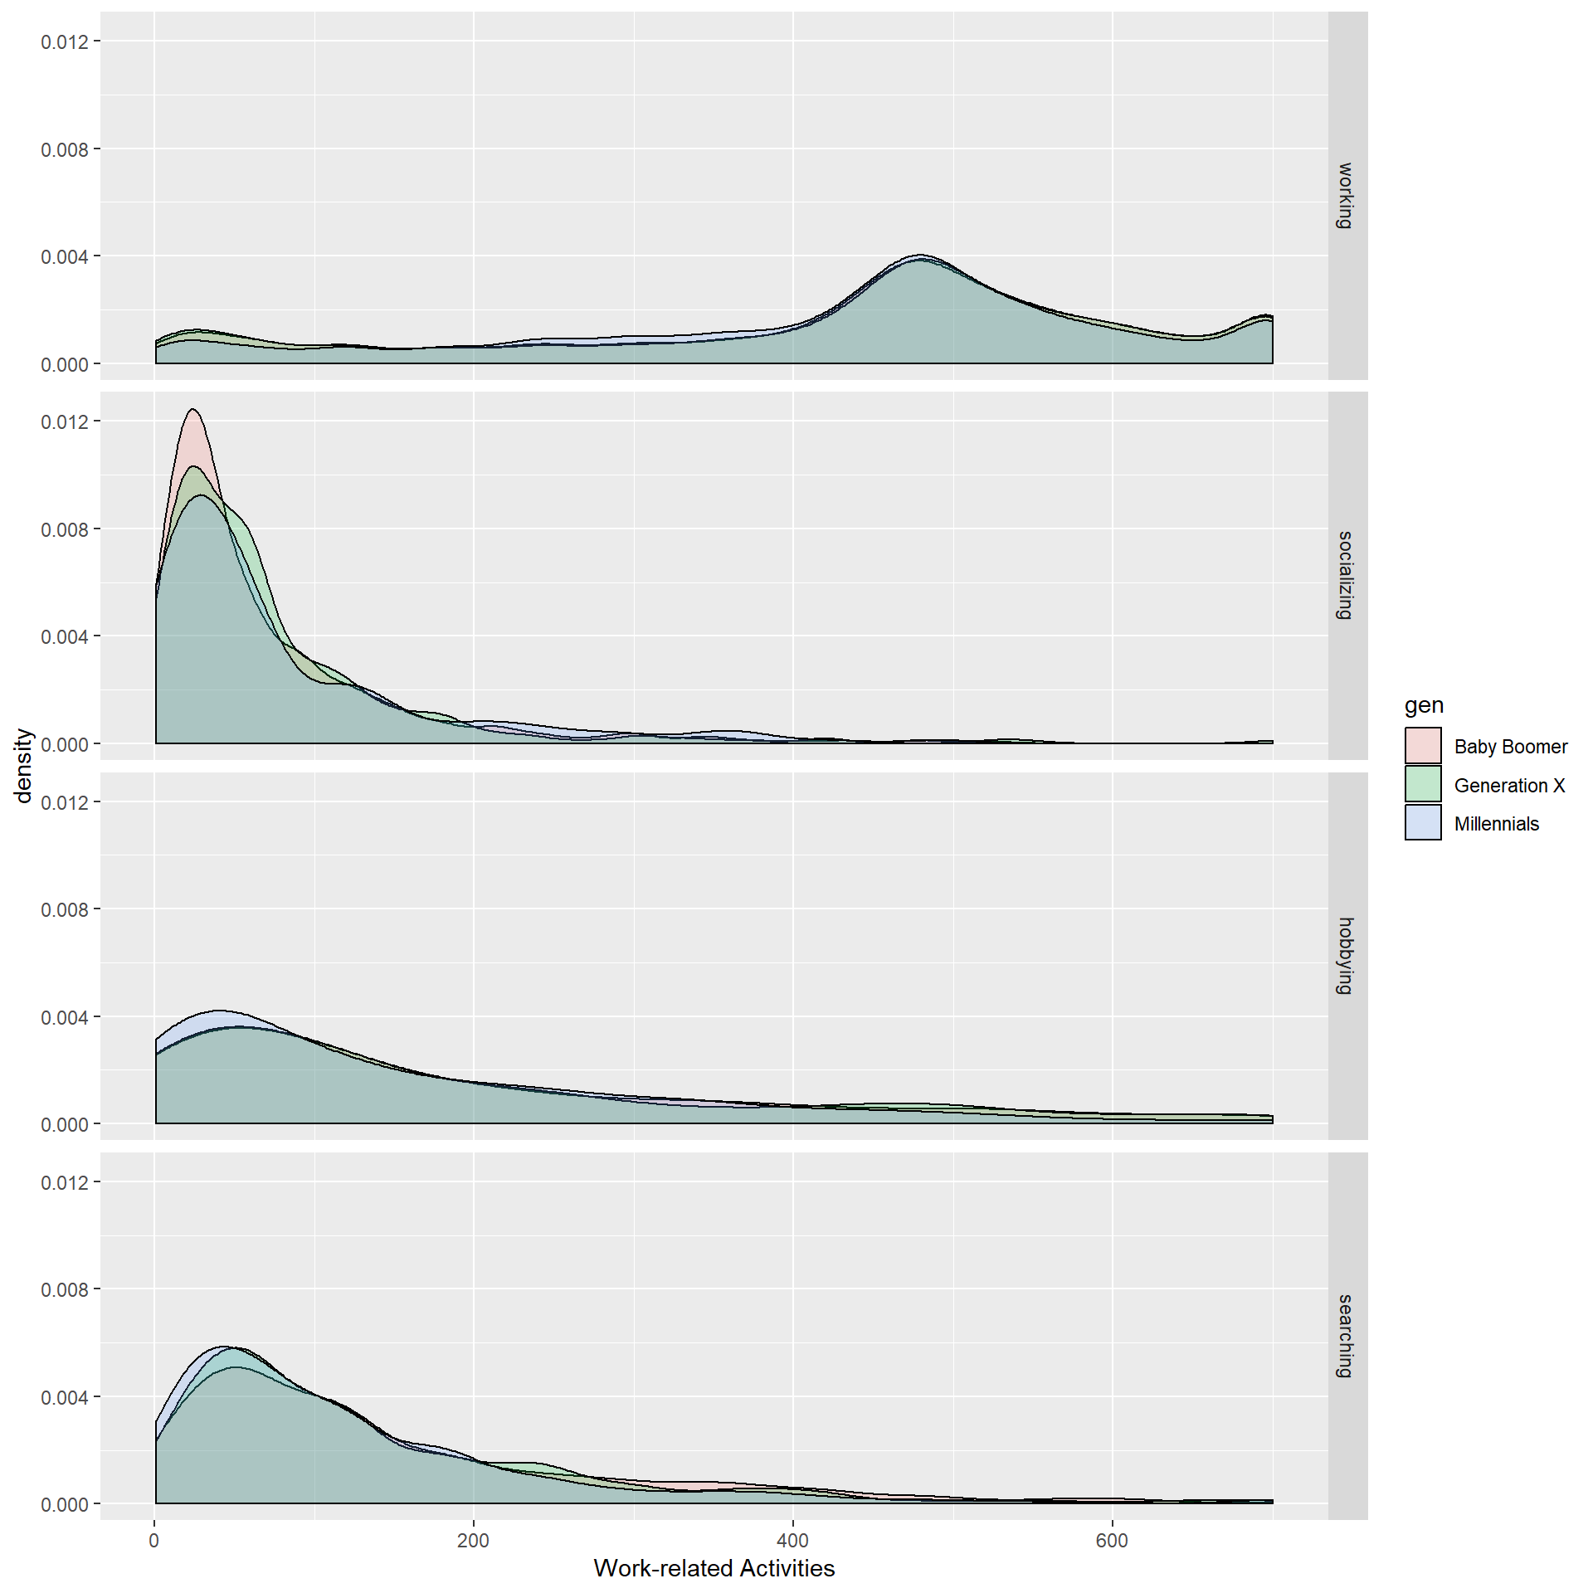

**Figure 2**

*Number of Minutes Spent Engaging in Work, Work-related Socializing, Income-relevant Hobbying, and Job Searching as a function of Generation and Age*

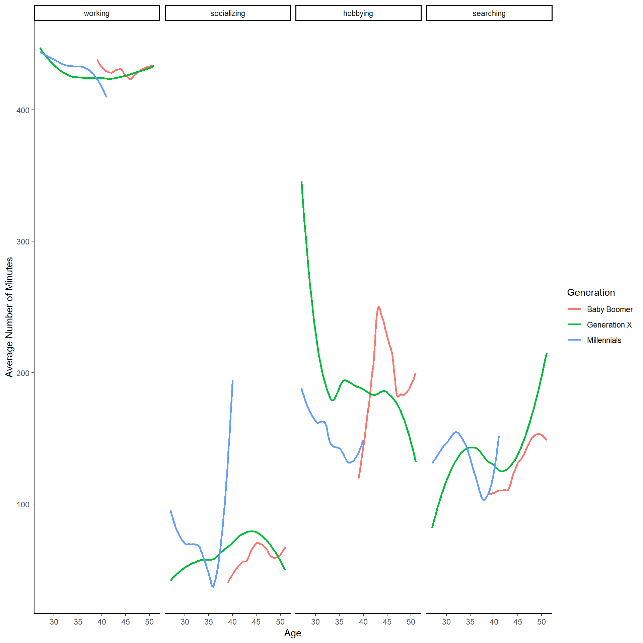

*Note.* Only a constrained range of ages that have multi-generational overlap are presented here.

|  |  |
| --- | --- |
| *Comment 1:* | This paper presented a novel way of looking at generational differences. It also acknowledged and attempted to address some of the biggest weaknesses of generational research (e.g., conflating generation with age). Though some of the writing was difficult to follow and I didn't get a great understanding of the main takeaway, I think this research will be of interest at SIOP. |
| *Comment 2:* | This paper attempts to disentangle myth from reality using interesting archival sources of data. However, it can benefit from more attention to operationalizing constructs, carefully constructing arguments and testing them with appropriate analyses. The following comments might strengthen future revised versions of the paper. It would help position or focus the paper more sharply, from the beginning (including the title) on the specific question being addressed: does work-life integration differ for millennials than for other generations? The idea of millennials is introduced without much definition or description - even if it is a widely understood idea, it would behove the authors to remind readers that 'generation' is a socially constructed idea, and differences exist in this idea of 'generation' between cultures and contexts. Especially given their source data, the authors must firmly position their study as one applicable only to American conceptualizations of 'generation' and 'millennials'. The definition of Millennials in most places includes those who were born in or before 2000 (hence the term!) - but not according to Table 1 here. But nowhere is this difference explained or addressed. Additionally, the authors don't acknowledge the frequent conflation between 'age differences' and 'generational differences'. This is attempted in the results section, but gives rise to more confusion than clarity in my mind. E.g. I'm not sure what this means! "Across the survey years, Millennial respondents ranged in age from 16 to 41, Generation X'ers ranged from 27 to 53, and the youngest Baby Boomers were 39 when the survey started in 2003." A little proof-reading/editing might help improve the flow and readability of the document. E.g. "The current paper presents evidence demonstrating that perhaps we are misguided in focusing on generational differences using self-reported indicators of work- and non-work attitudes." can be rewritten as "The current paper presents evidence (using self-reported indicators of work- and non-work attitudes) demonstrating that perhaps we are misguided in focusing on generational differences." to make it clear that the self-reports are the evidence, and not the generational differences! Another confusing example is this: "When assessing trends amongst millennials in the current literature, it is evident that there is a desire to integrate these two domains (Schultz, 2012)." Does this mean that millennials desire to integrate these two domains (and what two domains?!) or that those assessing trends desire to integrate the two domains? This research question is missing something crucial and does not make grammatical sense as written ("spending working"?): Are same-aged Millennials spending working more than other generations? Similarly, the correct use is "fewer" minutes (not "less" minutes). The 'working', 'socializing' etc. coding lexicon needs further elaboration. Finally, the analyses could have gone beyond the ones presented - given the potentially rich data collected. |
| *Comment 3:* | The definition of millennial should be at the beginning. Table 1 includes the age parameters, but it is not referenced anywhere else in the paper. The sample sizes are also not addressed in the table, figures, or measures section. The participant population, age, and city could describe why some millennials (and others) have multi-jobs. Your paper would benefit from additional proofreading, as there are words missing in several places. The use of parentheses within a long sentence can be distracting, so consider breaking those sentences into more than one. The Variables section was a little confusing to read, and did not address how the data was collected or consolidated; the definition of "security procedures" was unclear. Your paper would be stronger with more reference to the research questions in your discussion section. There is some commentary without references to literature or support for the conclusion (e.g., "perhaps due in part to technology"). It is unclear how other generations compare to millennials in thought and responses. Interesting topic that is of interest to many employers, as more millennials enter the workplace, and choose to promote within an organization. |
| *Comment 4:* | Nice job with setting up the focus - especially on the contradicting elements of what I tend to think of as being the millennial myth. The methodology seems sound - and is consistent with other research in this space - namely despite perceptual differences about millenials, there is a lack of consistent research to support these impressions. It would be good to look at the "older" vs. "younger" millennials as the cohort is quite broad in terms of age. All in all well done. |

1. Note that this data was trimmed from its raw form – all “zeroes” were excluded from these distributional representations and ANOVA analyses. For many work-related variables, however, the *most common value given* was, in fact, zero. Therefore, as an additional check on those who were not engaged in work-related activities at all, chi-square analyses of the percentage of “zeroes” by category across generations yielded a significant value only for minutes worked (χ22 = 244.4, *p* < .05; with Generation X having the lowest percentage of “0 minute” workers [52.5%], followed by Baby Boomers [57.1%] and Millennials [59.2%]).
2. Tukey HSD *p*-values were adjusted for multiple comparisons.